Real Estate CRM

Master Details -> Enquiry

1.Enquiry Form

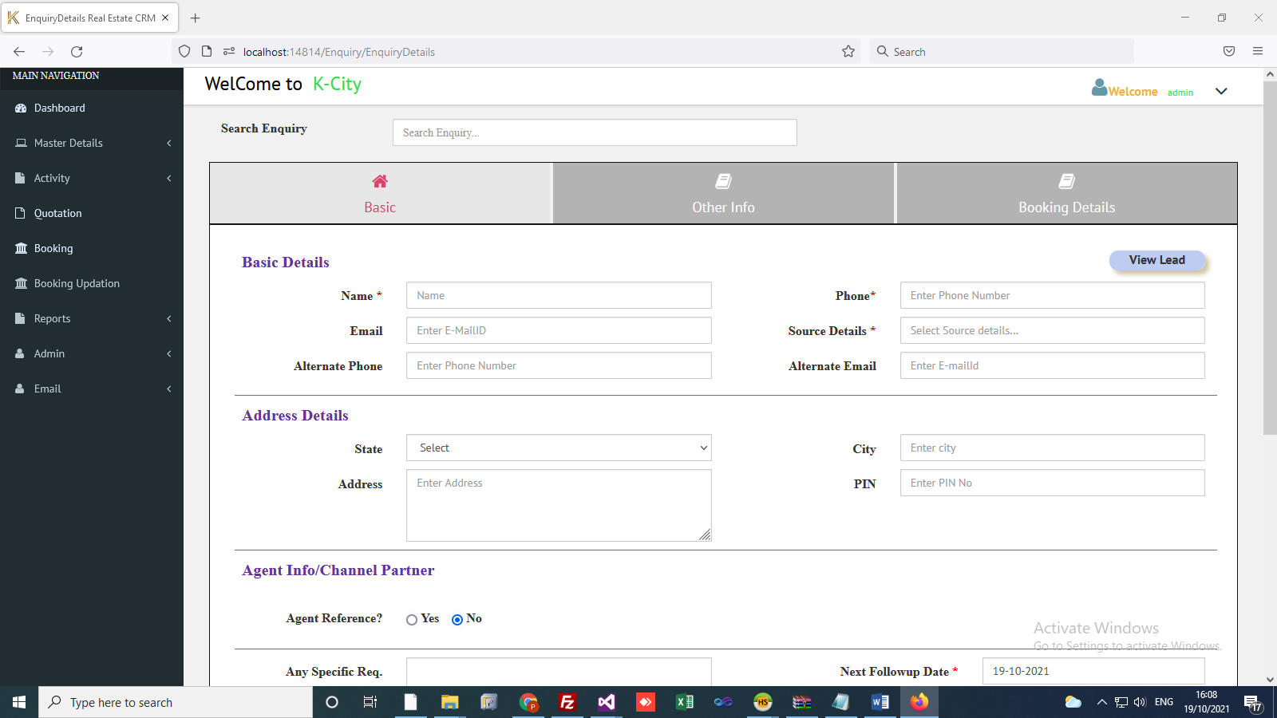

* Basic:
* Add new enquiry (* mark field Name, Phone number, Source filed compulsory).
* Update Enquiry (Filter : Name,Phone,Email ID)
* Basic Details, Address Details, Agent Info/Channel Partner, Requirements (Budget. etc.)
* Also we can open enquiry lead from here.
* Other Details :
* Enquiry Other Details
* Family Info, Professional Details, Other Details
* Booking Details
* Owner Details.
* These details are used in Booking Application Form.
* Also we can add owner documents.

Master Details -> Other Master

2. Other Master

* All Master details can be fill in other master.

Document Type

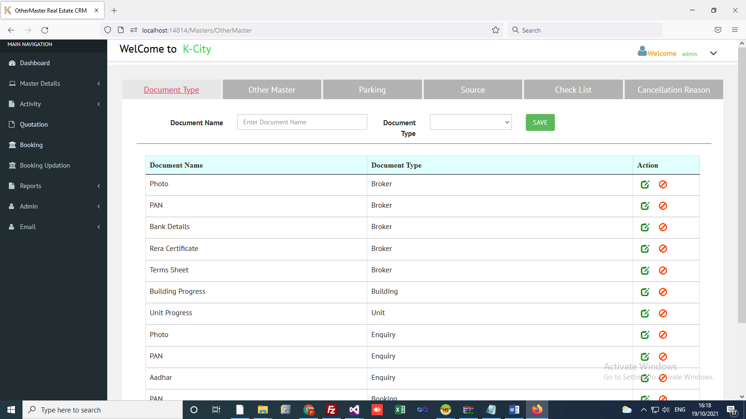

* Create,Update,Active and Inactive document type.

Other Master

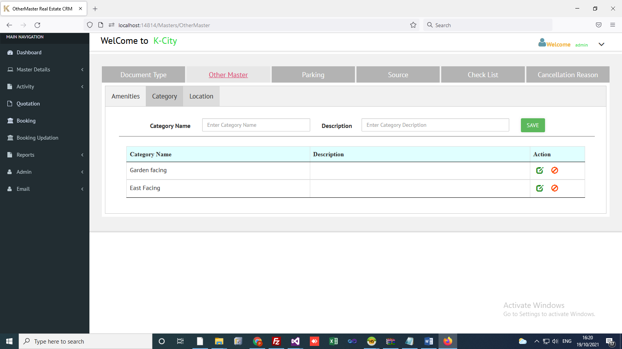

* Amenities, Category and Location
* This are used in Project info, Building Info and channel Partner Info respectively.

Parking Master :

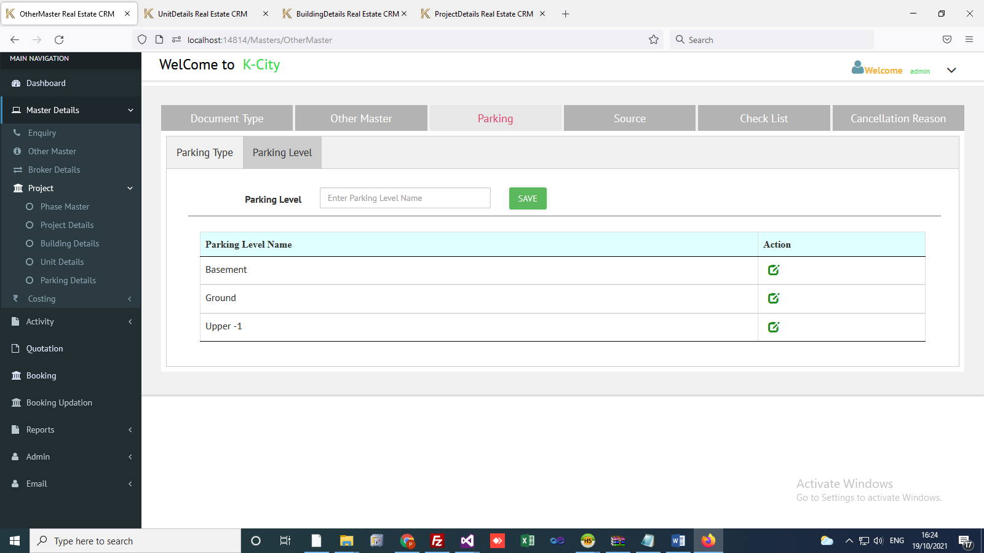

* We can add parking type and Parking Level here.
* These are used in Parking Details.

Source Details:

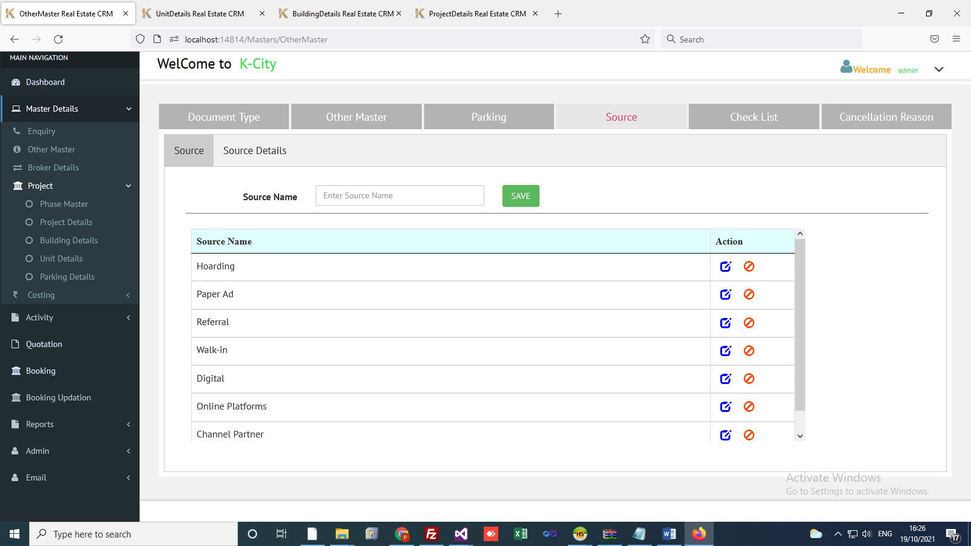

* We can create source and source details here.
* These are used in enquiry master.

Checklist Master

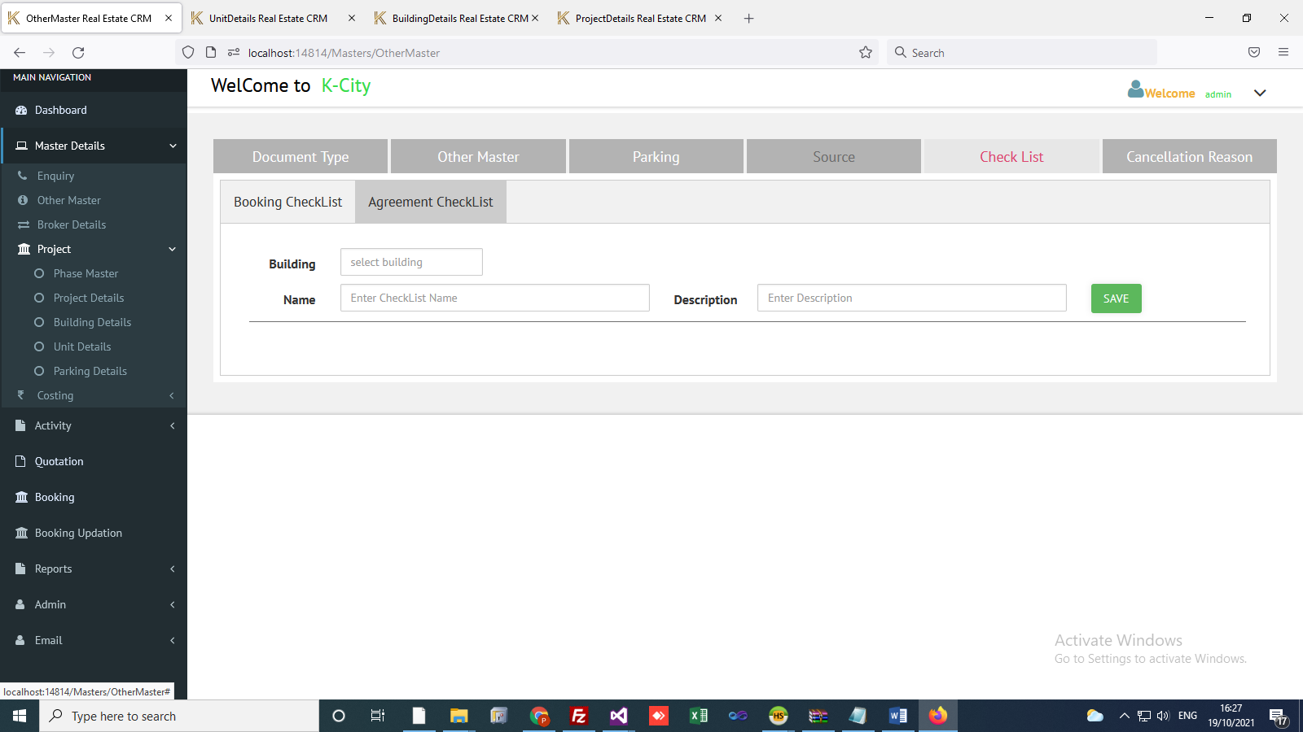

* We can create Booking and agreement Checklist here.
* Used to taking booking and agreement related documents from enquiry.

Cancel Reason

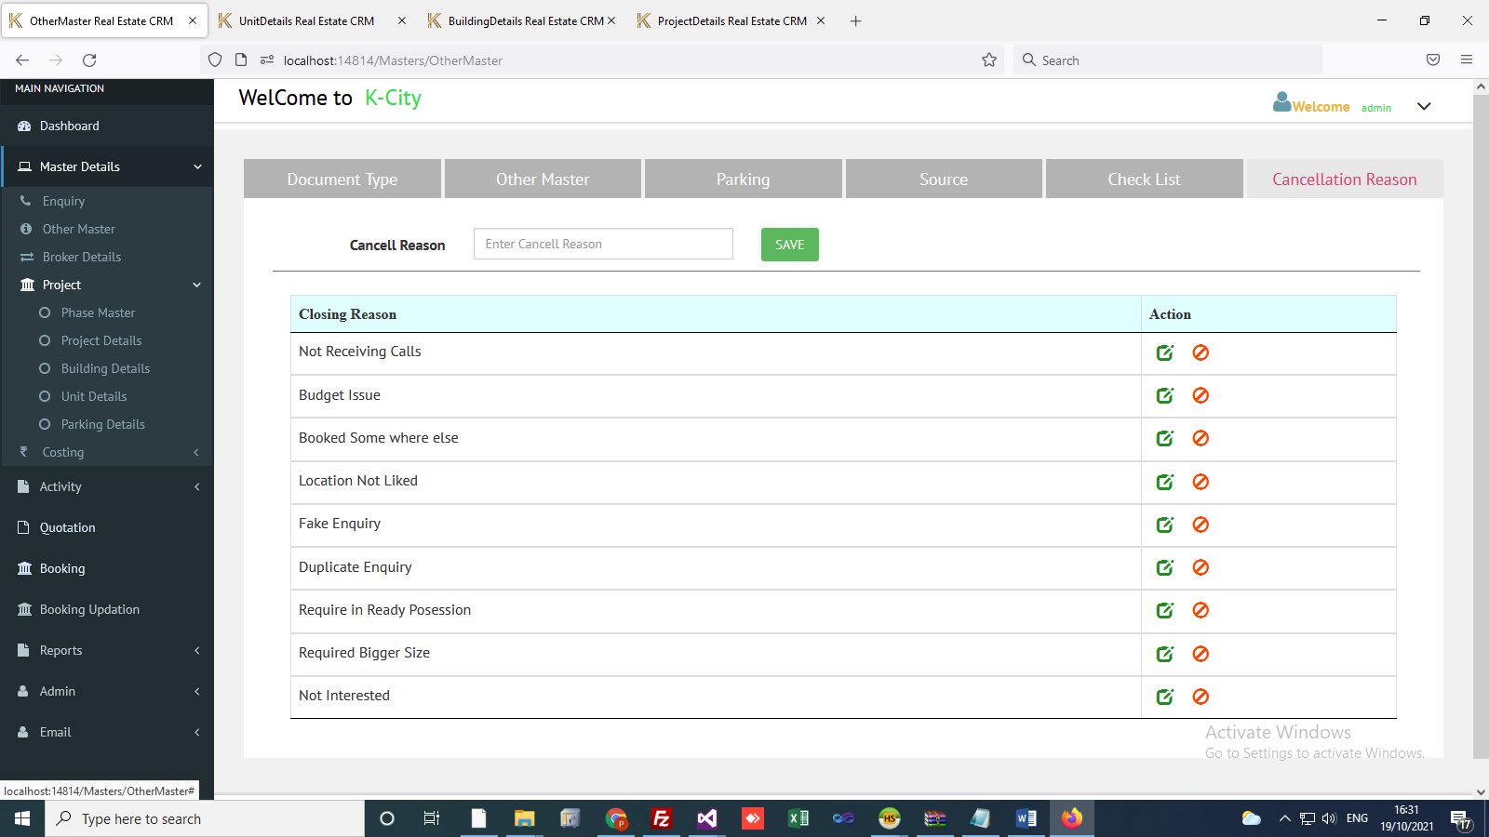

* Enquiry cancellation/Close reason.

Master Details -> Broker Details

3. Broker Details:

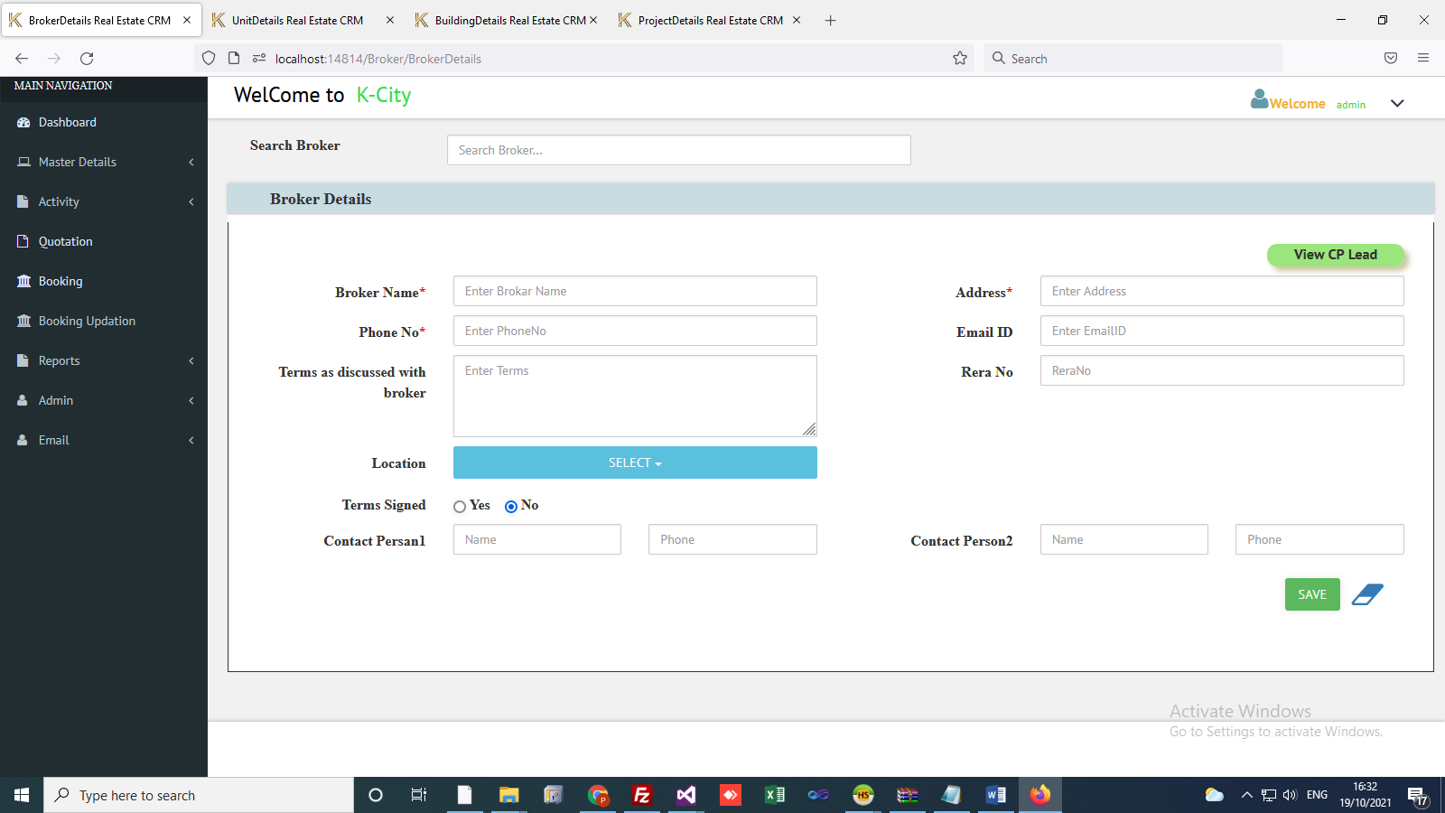

* Add new Broker Details (* mark field Name, Phone number, Address filed compulsory).
* Update Enquiry (Filter : Broker Name)
* Also we can add broker related documents here.
* Also we can view current Broker lead details from here.

Master Details -> Project ->

4. Phase Master

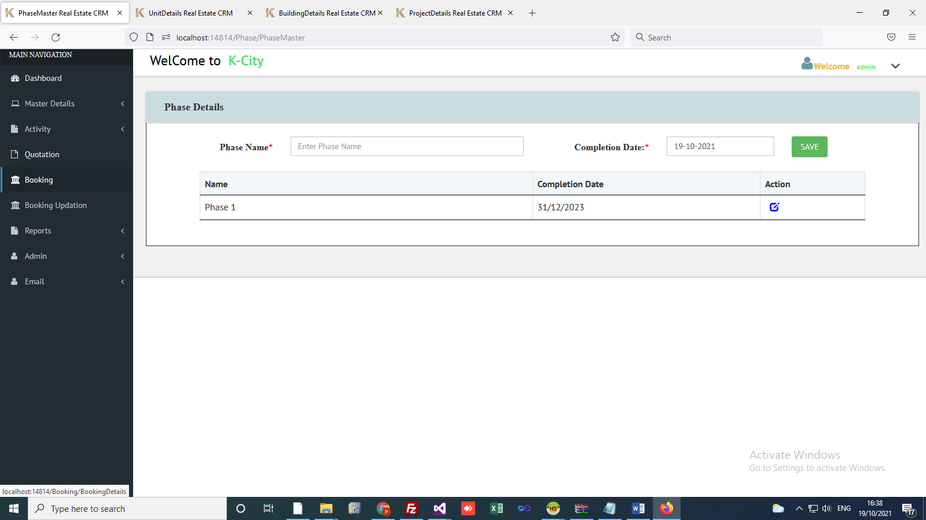

* Create/update phase master.

5. Project Master

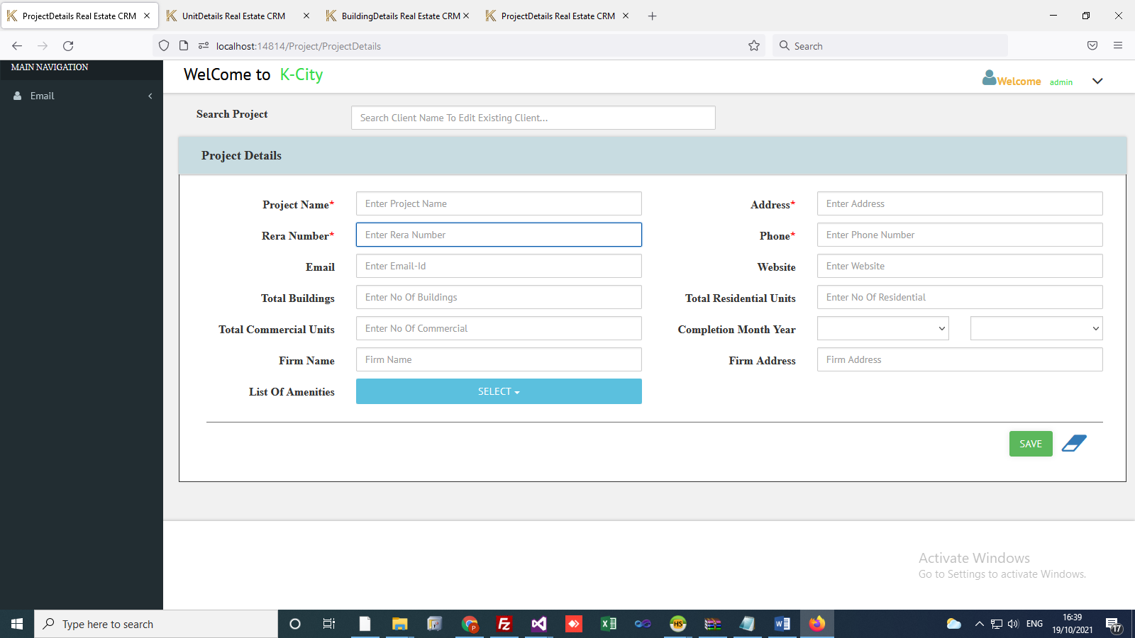

* Create / Update Project Related details.
* Project Name, Address, Rera Number, Phase fields compulsory.
* We can add total buildings, units, Firm Name, Firm Address.

6. Building Details: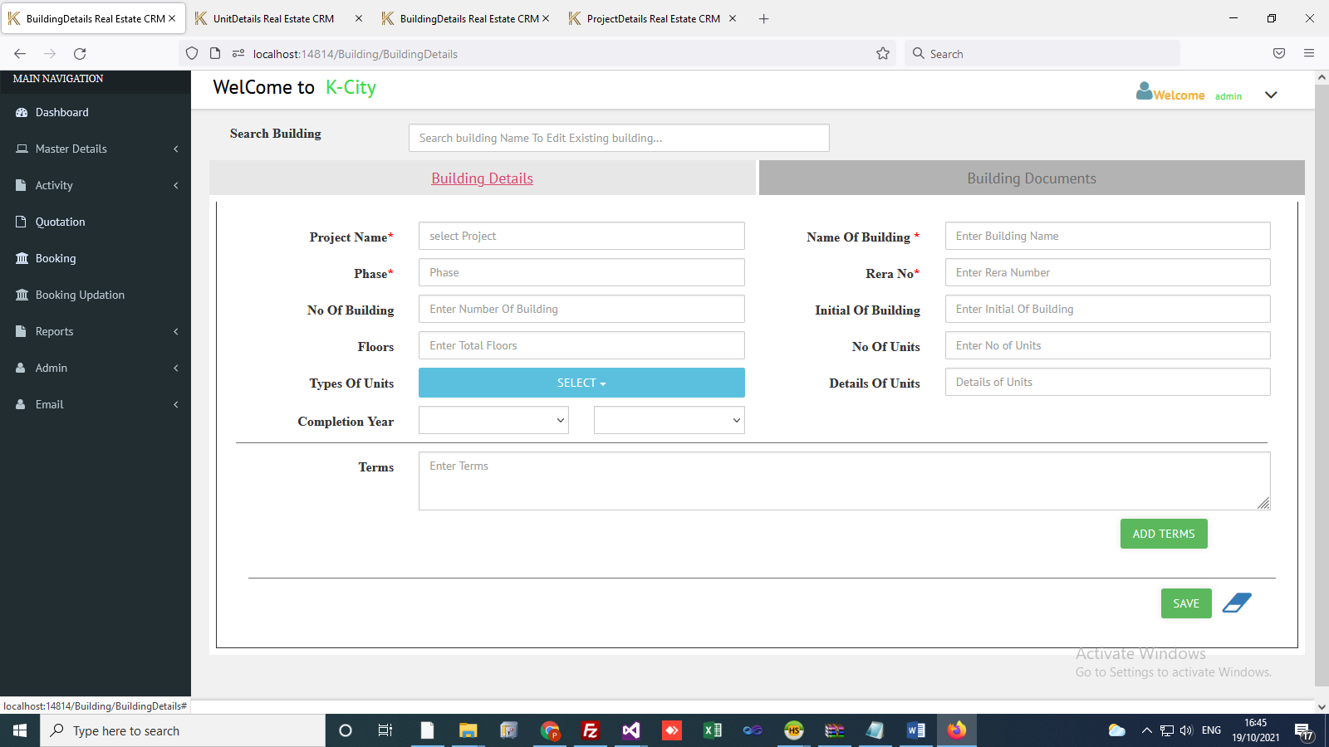

* Create / Update Building Details.
* Project Name, Building name, Phase, Rera Number compulsory fields.
* Also we can add building related Documents.
* Building related Terms.

7. Unit Details

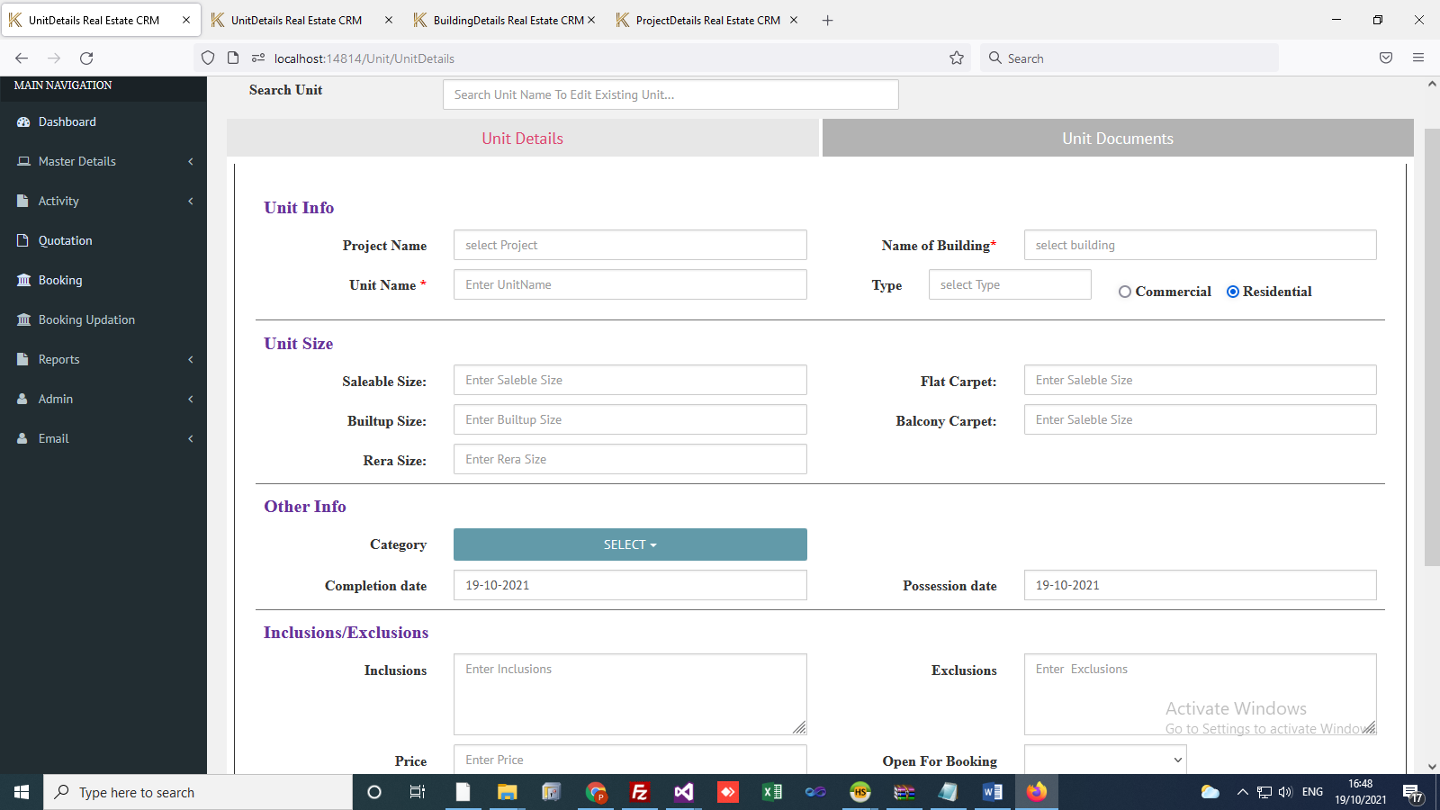

* Create / Update Unit Details.
* Building Name, Unit Name compulsory fields.
* Unit Size : Saleable Size, Built-up Size, Rera Size, Flat Carpet and Balcony Carpet.
* Saleable size and Unit Price is used in base price calculation cost.
* Flat Carpet and Balcony Carpet used in application form.
* Also we can add Unit related Documents.
* Unit related Terms.

8. Parking Details

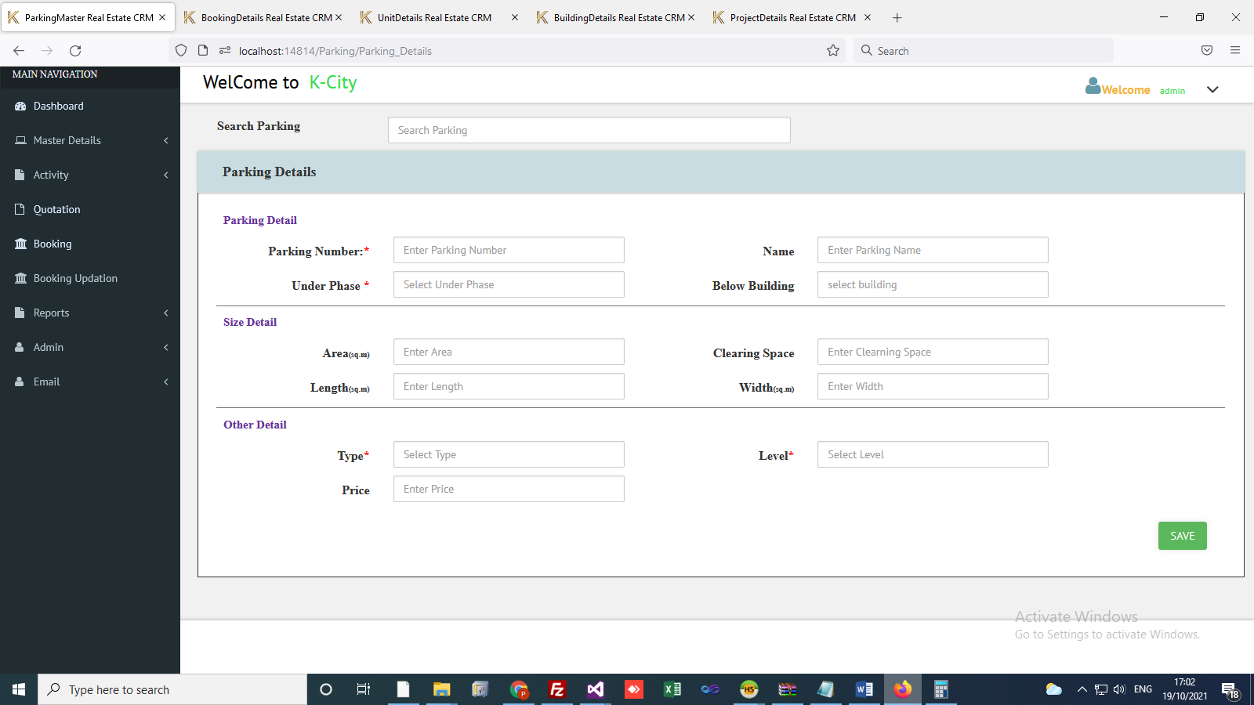

* Create / Update Parking Details.
* Parking Number, Under Phase, Type and Level compulsory fields.
* Define area, clearing space, Length and width of Parking.
* Also we can add type of parking and Level of Parking.

9. Other Charges

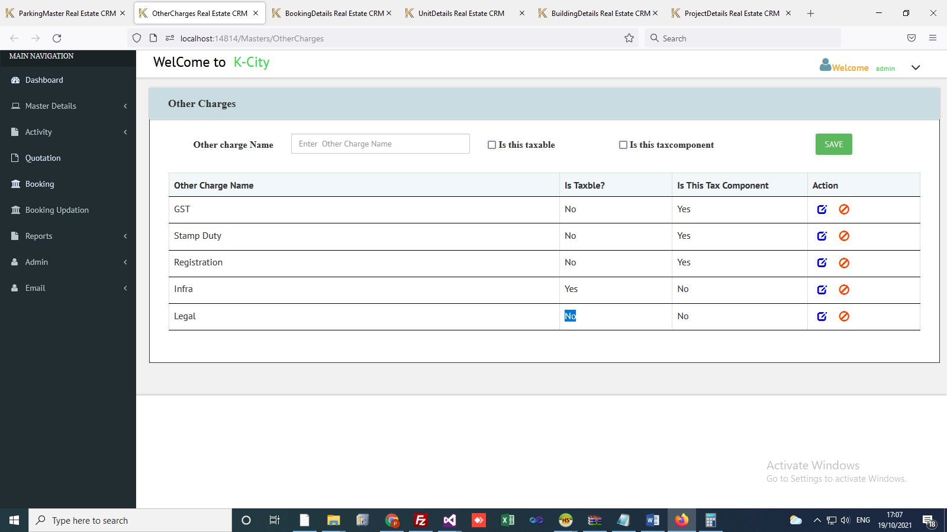

* Create / Update other charges master.
* Is Taxable: Tax calculated on this amount.
* Tax Component: GST, Stamp Duty.

10. Building Other Cost

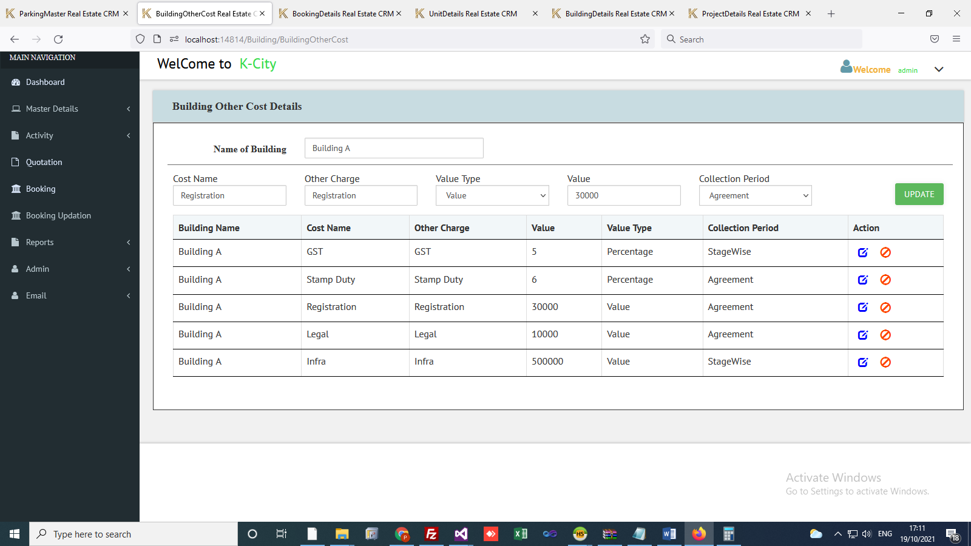

* Create/Update Building Other Cost.

11. Unit Other Cost

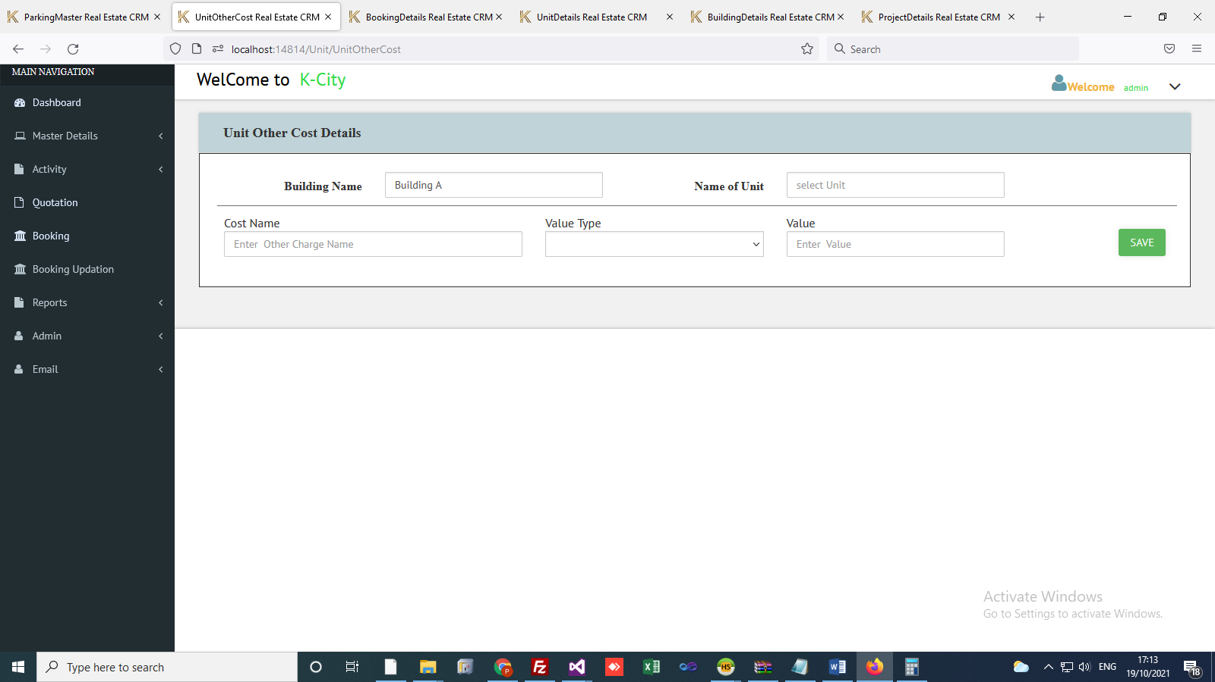

* Create/Update Unit Other Cost.

12. Building Schedule.

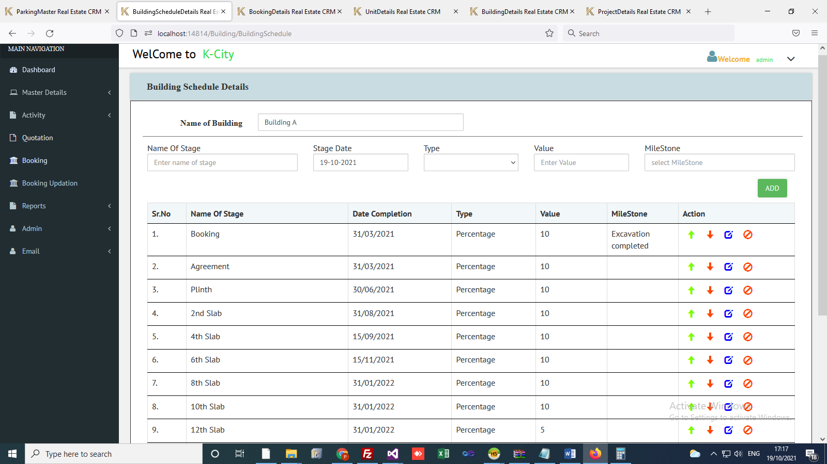

* Create/Update Building schedule.
* Percentage value must be 100% total of all stages.
* Map milestone for each building schedule. It is used in Mile stone completion Form so we can raise demand for each completed mile stone.

Lead

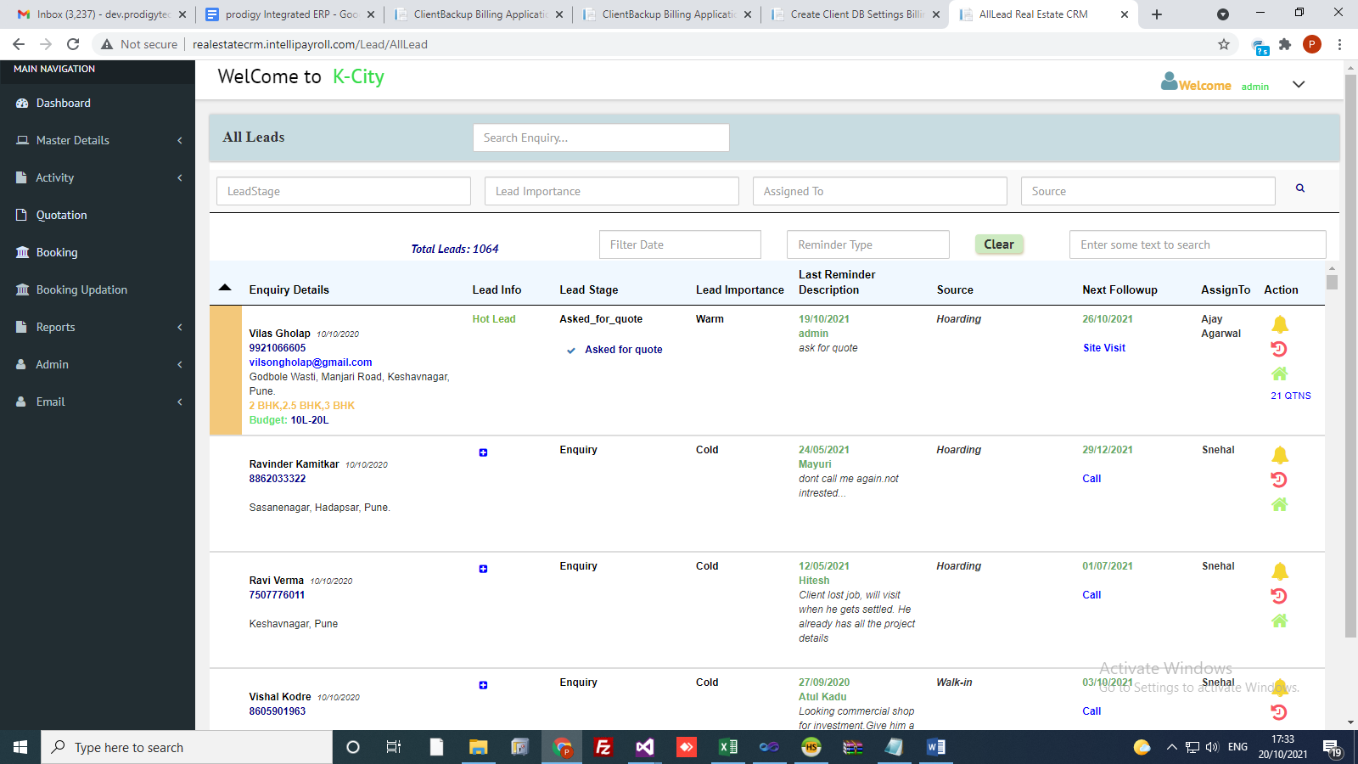

* Create reminder for Lead.
* View Reminder history.
* Choice Selection, Block Unit.
* View Quotations.
* Also we can add extra lead information in **Lead Info** column.
* Colour coding depends on lead importance (Cold, **Warm,** Hot).

CP Lead

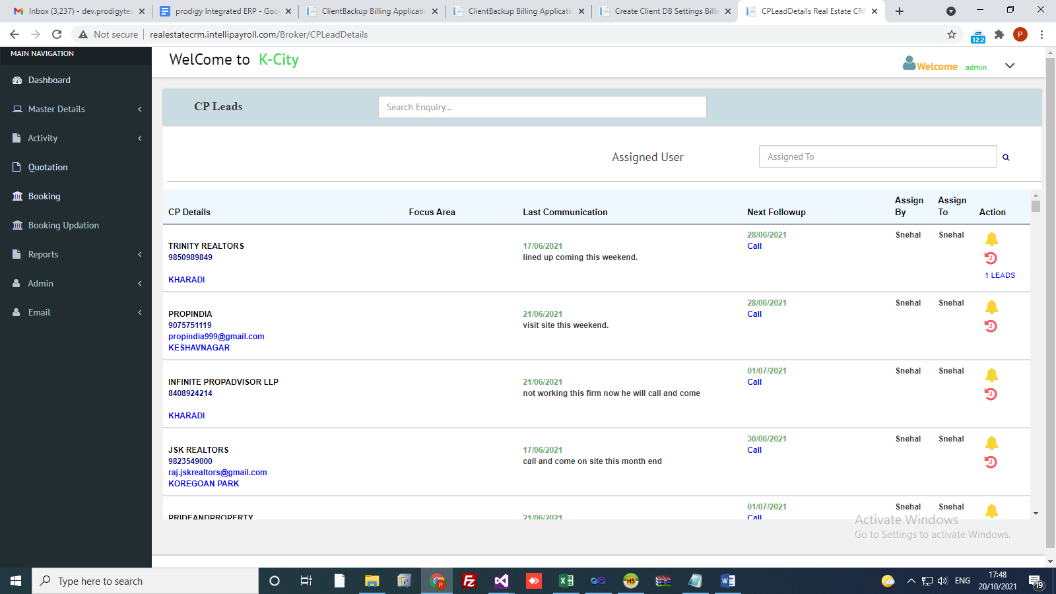

* Create CP Reminder
* View Reminder history.
* We can see Leads which came from Cp.

Cancel Enquiry

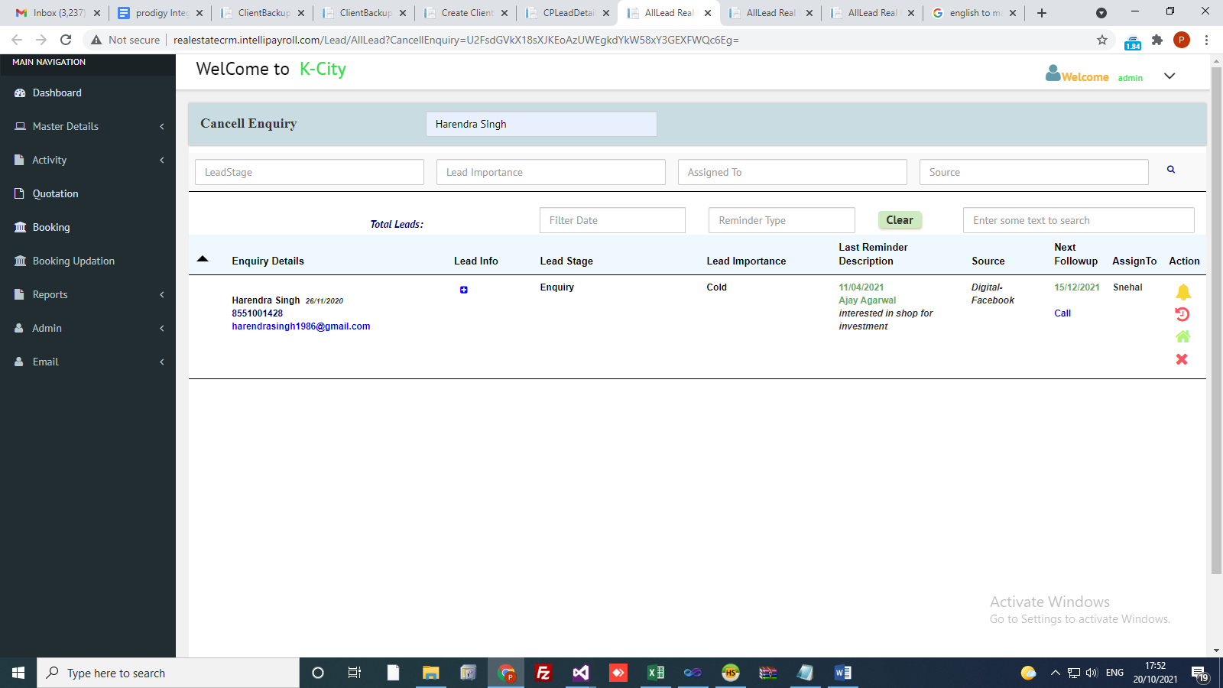

* We can cancel the enquiry using this form.
* Select closing reason required for cancel enquiry.

Transfer Lead

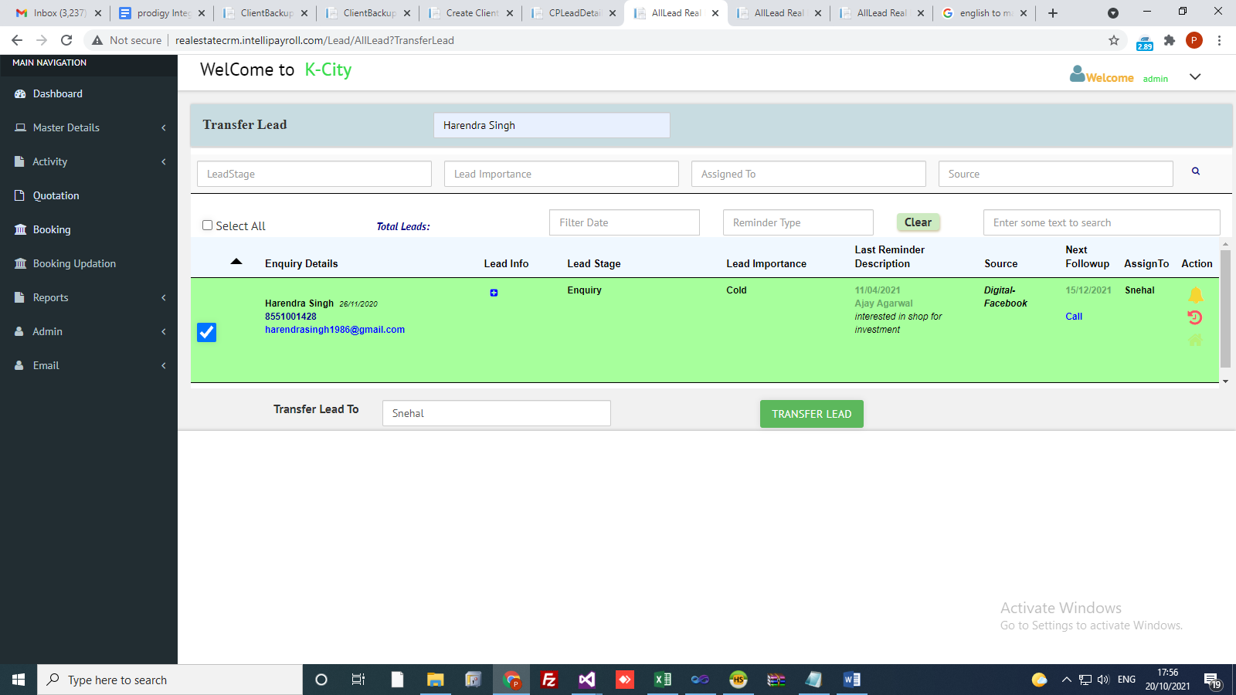

* We can also transfer lead to other users.
* Select lead and select user to transfer lead.

Payment Process

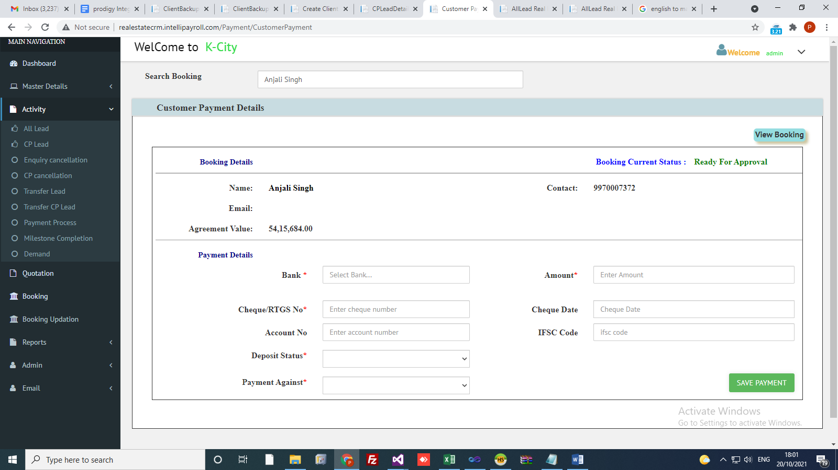

* We can only Search those enquiries which are booked the units.
* Show Booking details (Enquiry Name, Agreement value).
* Enter Payment details and Save the Payment.
* Also showing list of payments which are not cleared.so whenever payment is clear then we can update the status of payment.
* Also we can view booking details of that enquiry.
* If Payment is clear then need to provide payment/cheque clear date.

Mile Stone Completion

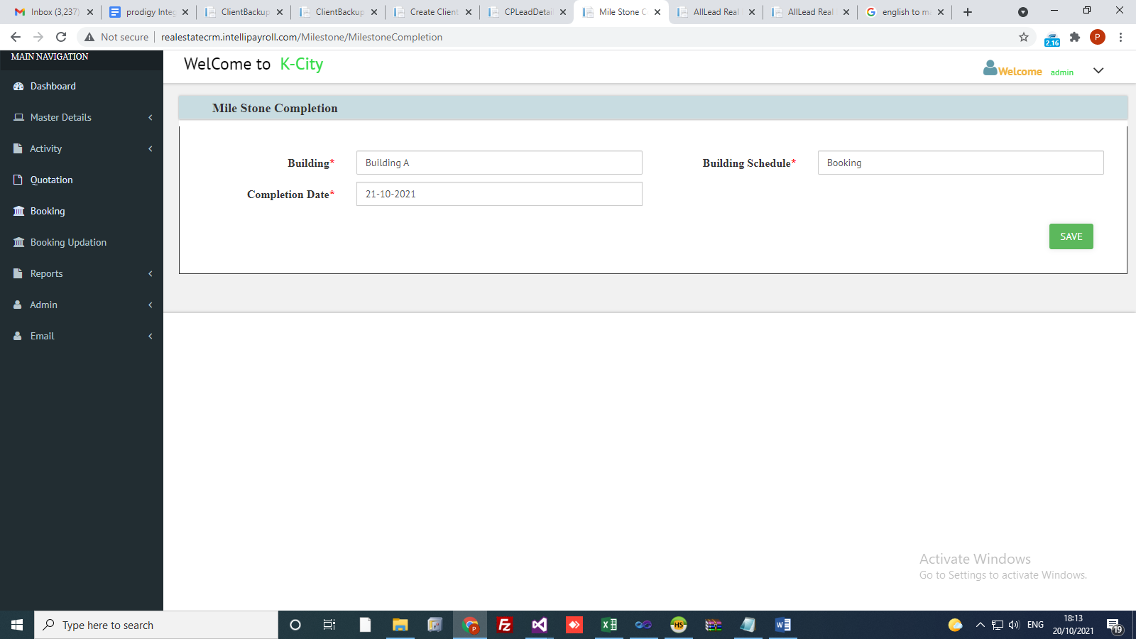

* For every building schedule we can link the schedule with the milestone.
* Here we can insert milestone completion details.
* Select building, building schedule and its completion date.

Demand

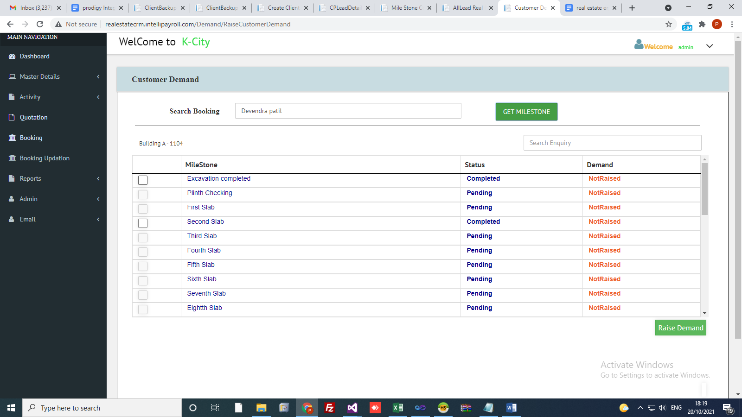

* Once the milestone completed we can initiate the demand raising.
* We can raise the demand as per the schedule and completion of work.
* We cannot create the demand whose milestone is not completed.
* Also we can save generated demand.
* In Demand we show Total agreement value and Total GST Value.

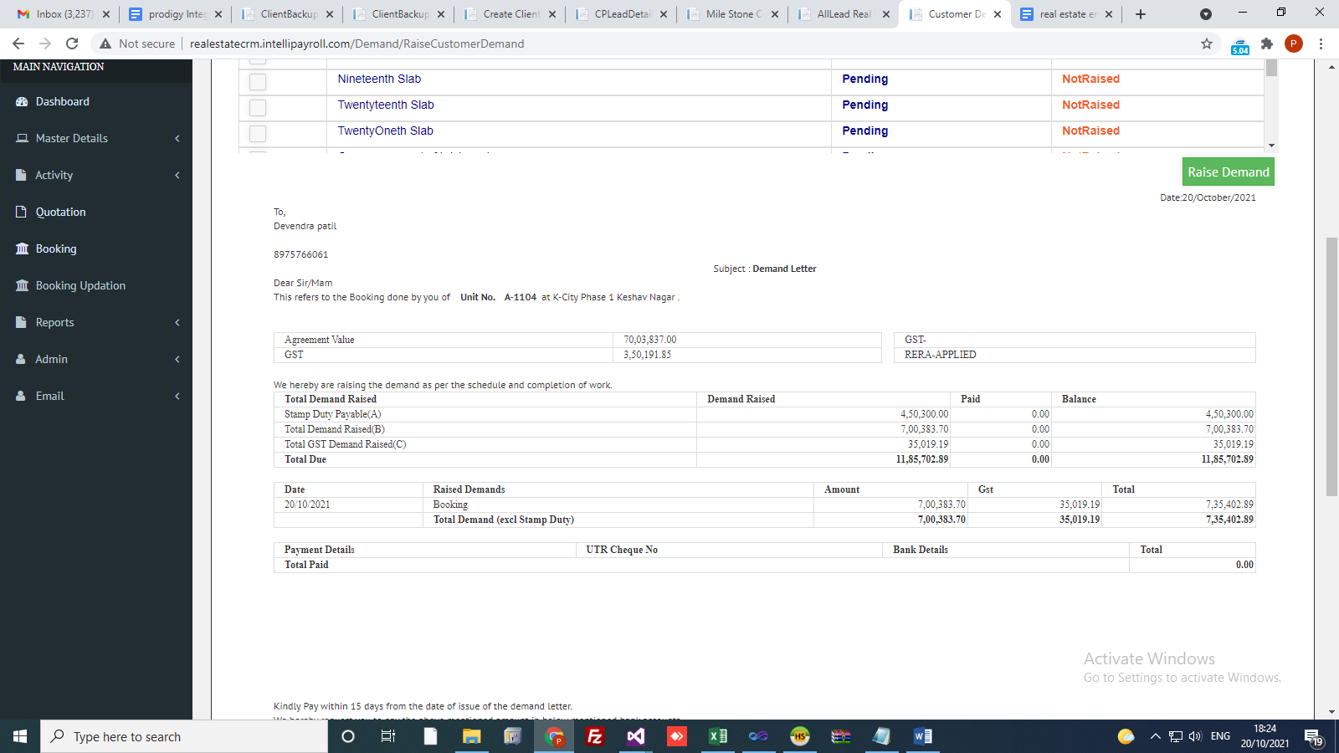

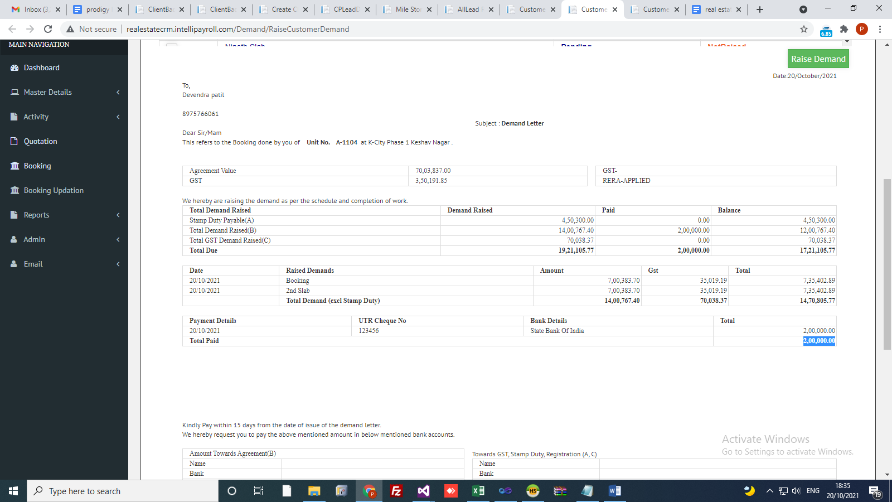

* Previous demand paid amounts are shown here.
* Also we can show Payment details on demand.